|  |  |  |  |  |
| --- | --- | --- | --- | --- |
| National University of Computer and Emerging Sciences, Lahore Campus | | | | |
|  | **Course Name:** | **Professional Practices in IT** | **NAME:** |  |
| **Quiz** | **3** | **ROLL NO:** |  |

**Scenario**: A social media platform uses data from user profiles and interactions to create personalized ads. Some users complain about privacy invasion.

**Question**:"In response to user concerns about privacy and data use for personalized ads, what approach should the social media platform take?" [2]

**a**. Continue the current practice but offer users a premium ad-free version of the platform.

**b**. Provide comprehensive information about data usage, obtain explicit consent, and offer an easy opt-out option for personalized ads.

**c**. Limit ad personalization to user demographics and location data, assuming implicit consent.

**d.** Switch to random ad placements without using personal data, potentially reducing ad relevance and effectiveness.

**Question2**: Why do employers monitor workers? Do you think they should be able to do so? Why or

why not? [2+2]

Why? To monitor productivity and illegal activities.

Why not? The monitoring can cross the line by acts like camera monitoring without informing.

**Scenario**: A political blog, operating anonymously, publishes a series of articles alleging corruption in a government agency. The articles are based on what appears to be leaked internal documents. The government agency, claiming a breach of national security, files a John Doe lawsuit seeking to subpoena the hosting service for the blogger's identity.

**Question**3: "In this John Doe lawsuit, what critical aspects will the court likely examine to decide on the subpoena request?" [2]

**a**. The court will assess if the blog's speech falls under the protection of the First Amendment or if it constitutes a clear and present danger to national security.

**b**. The subpoena will be automatically granted due to the involvement of a government agency alleging national security concerns.

**c**. The court will prioritize the blogger's right to anonymous speech, denying the subpoena unless direct incitement to imminent lawless action is proven.

**d**. The subpoena will be contingent on whether the leaked documents are classified, regardless of the First Amendment implications.

**Question 4:** Outline a scenario in which you might be acting ethically but might still want to remain anonymous and in another situation where you are having an illegal expression while being anonymous using the Internet **[2+2]**  
First scenario: Finding support for some mental disorders, participating in sensitive debate or reporting illegal activities of employer.

Second scenario: Defamation or exposing minors to inappropriate speech.

Any other closely related to mentioned above.

Question: How do you distinguish between a gift and a bribe? Provide an example of a “gift” that falls

in the gray area between a gift and a bribe. [2+2]

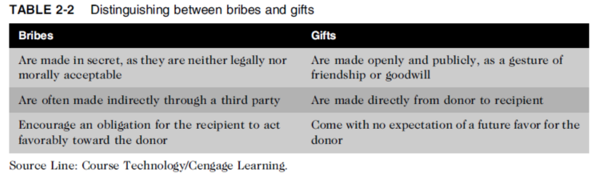

Any example which can fall under both based on above points.

Question: You are an experienced, mid-level manager in your firm’s IT organization. One of your responsibilities is to screen résumés for job openings in the organization. You are in the process of reviewing more than 100 résumés you received for a position as an Oracle database administrator. Your goal is to trim the group down to the top 10 candidates to invite to an in-house interview. About half the résumés are from IT workers with less than three years of experience who claim to have one or more Oracle certifications. There are also a few candidates with over five years of impressive experience but no Oracle certifications listed on their résumés. You were instructed to only include candidates with an Oracle certification in the list of finalists. However, you are concerned about possible résumé inflation and the heavy emphasis on certification versus experience. What would you do? [2+2]

Verify Certification Claims

Suggest Enhanced Evaluation Methods: Propose including a technical skills assessment or interview phase to evaluate the practical knowledge of both certified and experienced candidates. This can address potential gaps in either group.